

**NET320-Database Systems**

**SWS213-Database Design**

**Lab 2b**

**Lucid Chart Introduction**

## Objective

Upon successful completion of this lab the student will be able to:

* Create charts/diagrams in Lucid software

## Background

Free ER Diagram Tool

Lucidchart's ERD tool makes database modeling fast, efficient, and collaborative. Start from scratch or with a template to easily draw ER diagrams online.

Nothing to install

Say goodbye to the hassles of desktop software. No more outdated versions, lost files, and resource drains. Lucidchart is always online and just a click away.

Drag and drop

Drag-and-drop functionality simplifies the entire experience. For example, line drawing is as easy as dragging from the edge of an object. Let go and a new shape instantly pops up.

## Software Required

Lucid Chart

References

https://www.lucidchart.com

## Task 1 - Creating a username and password in LucidChart website.

1. Students should open <https://www.lucidchart.com/> and select the option ‘SIGN UP FREE’

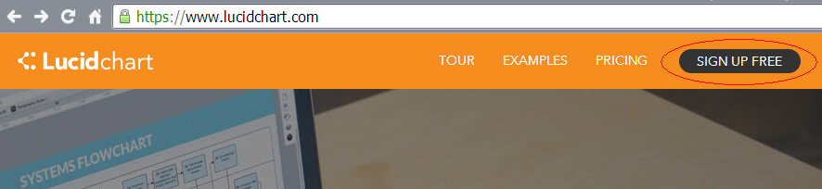

1. Select ‘START FREE ACCOUNT’



1. Enter Name, Email and Password.

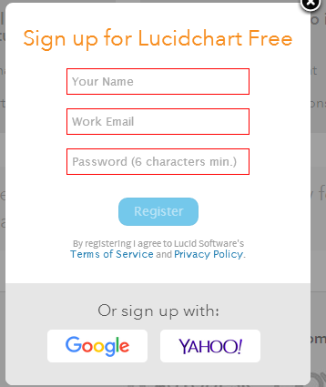

1. Enter the details and login to Lucid chart with your credentials.
2. Once you are in, Select ‘Entity Relationship(ERD)’and select ‘Start Drawing’.

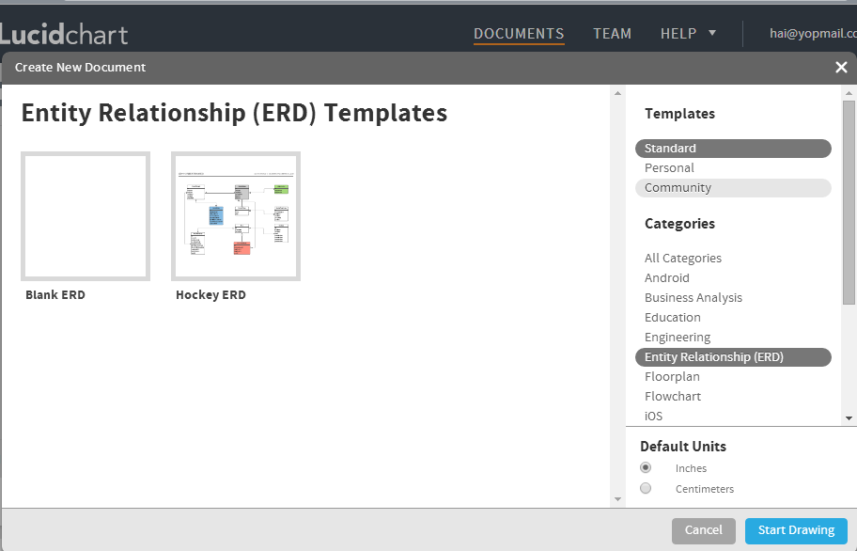

1. Go through the tips on screen.

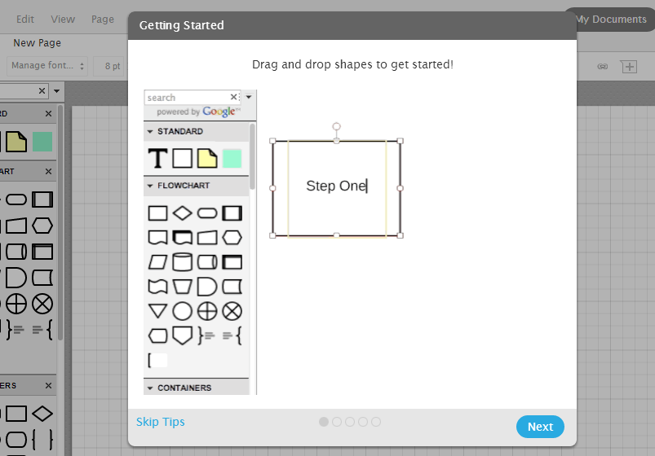

# Task 2- Create a sample LucidChart diagram

1. Create the sample diagram in Lucid Chart.

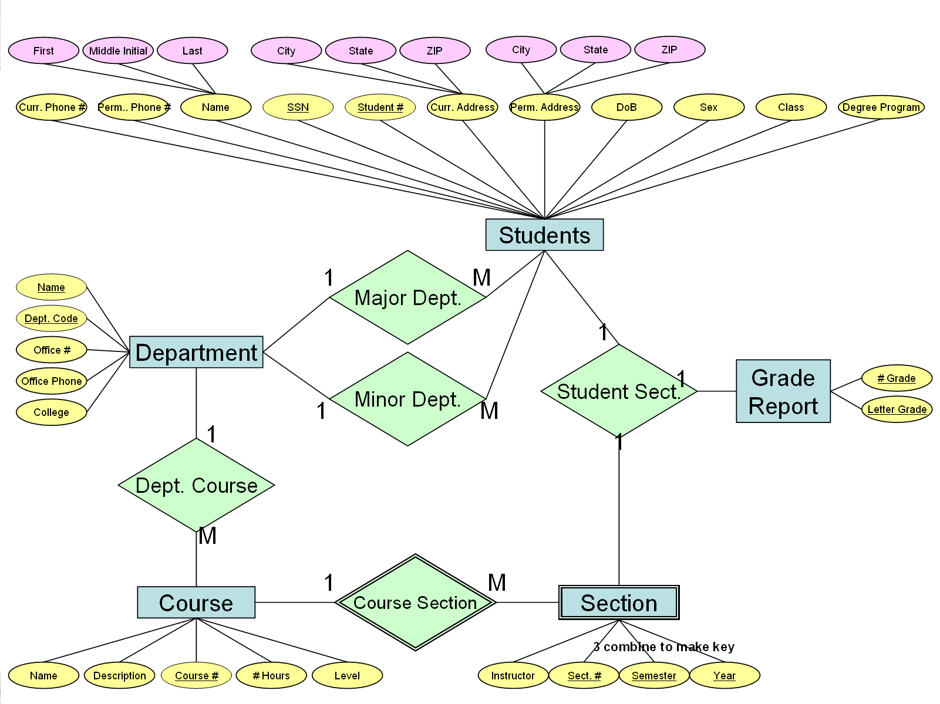

1. Download the file from Lucid Chart. Make sure the file downloaded as JPEG format.
2. Rename the downloaded file to your name followed by your ID.
3. Upload to moodle.